OOP Assignment 1c Report

Question 1

Question 2

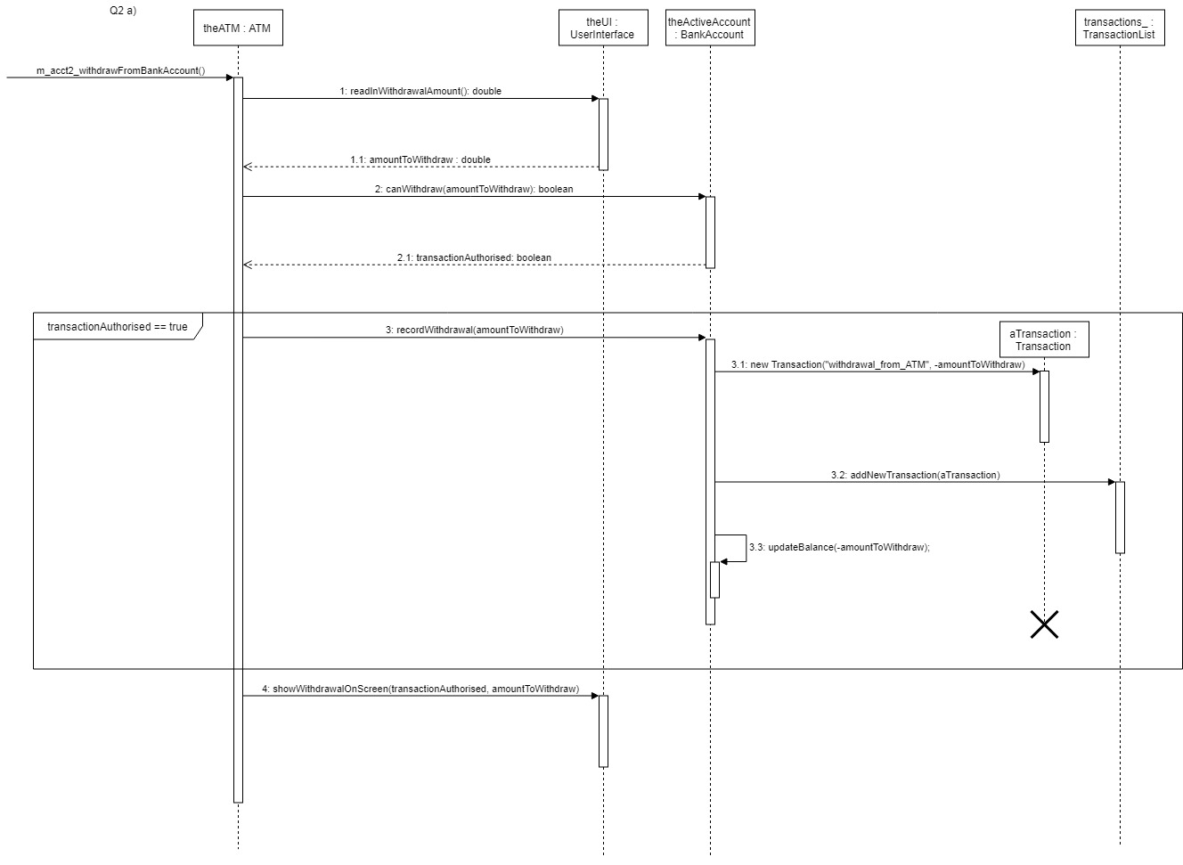

Question 3

Question 4

Question 5

Version control log

Notes:

1. A Word document for your group report containing your answers to Question 1, the UML diagrams for Question 2, C++ code extracts for Questions 3, 4 and 5 plus a version control log.

Answer questions about code provided: You must justify your answers to get the marks on this question.

UML diagrams: You must adopt the diagram conventions presented in class or specified in this document. However, if necessary, you can use English to complement your explanations so long as they are clear and unambiguous. You can produce the diagrams by hand or use tools such as Visio, Rational Rose or Together to help you.

C++ code: You must include the code for the required header files and specified function definitions.

Version Control Log: This report, automatically generated by the tool you have used to support the version control for the group work, lists the changes made by the various members of your team. It will be used to evidence individual contributions to the group work. So when make sure that the log information documents actual members' contributions.

Report: This report is to be presented on A4 paper typed, stapled (easily accessible for adding comments), paginated and identified with your assignment group number (e.g. SE1, CS4G3) and names of group members clearly indicated.